Week 02

This week we are diving more into simple linear regression and making predictions using one or two features.

Recommended Readings/Videos:

ML Fundamentals and ML Lifecycle

AI vs. Machine Learning vs. Deep Learning
Lecture Week 02
Slides

Assignment:

Here is the rubric for the assignment (Linear Regression, Data Cleaning, and Feature Engineering)
References:
https://www.kaggle.com/learn/intro-to-machine-learning Links to an external site.
https://www.kaggle.com/competitions/home-data-for-ml-course
Links to an external site.
https://www.kaggle.com/competitions/house-prices-advanced-regression-techniques

Goal: Use suitable regression data set to predict house values
Use 1-2 features to base the decision

Steps:

- Pick dataset and load it
- Find any errors or missing values
- List outliers with selected features
- Select a numerical value/feature to base a new feature on
- Split the data into training/testing sets
- Train linear regression model using cleaned/engineered features
- Calculate the model’s performance using 2 regression metrics i.e MSE or R2
- Create scatter plot to show original data points then overlay regression line generated from model
- Upload to GitHub, add readme
- Record video of explaining the feature engineering step
- Show model training and final metrics
- Run two test cases

Loaded Jupyter Notebook after navigating to /classes/ad331/week-02/…
Using toolbox, able to create a new environment for the dependencies.

To get started, I chose a dataset from Kaggle - KC House Data. Downloaded and put into the same folder structure as my synced repository/jupyter notebook. (Imported dependencies and dataset) Loaded dataset, identified and validated data, and looked for any errors with values off the bat.

Important to use the ML Lifecycle:

Step 1: Plan
Decide what to predict (in this case, future house prices) and understand the data you will use (the selected features)

Step 2: Explore the Data
Load the dataset, check/validated data types, look at summary statistics, identify errors or missing values, then create visualizations of the data

Step 3: Clean the Data
Find missing values and decide to drop or include, remove/handle outliers, and check data quality

Step 4: Select the Features & Engineer
Features (x) = choose the columns that predict the target
Target (y) = the target, which is the house price
Create new features from existing data

Step 5: Build the Model
Define the model type (linear regression), train the model on testing data, then measure performance of the model

Step 6: Validation
Split the data (train/test split can be 80/20)
Calculate the metrics (MSE, or R-squared)
Test if model is achieving goal and meeting standards

Step 7: Visualize
Make plots, predictions, graphs, and create analysis

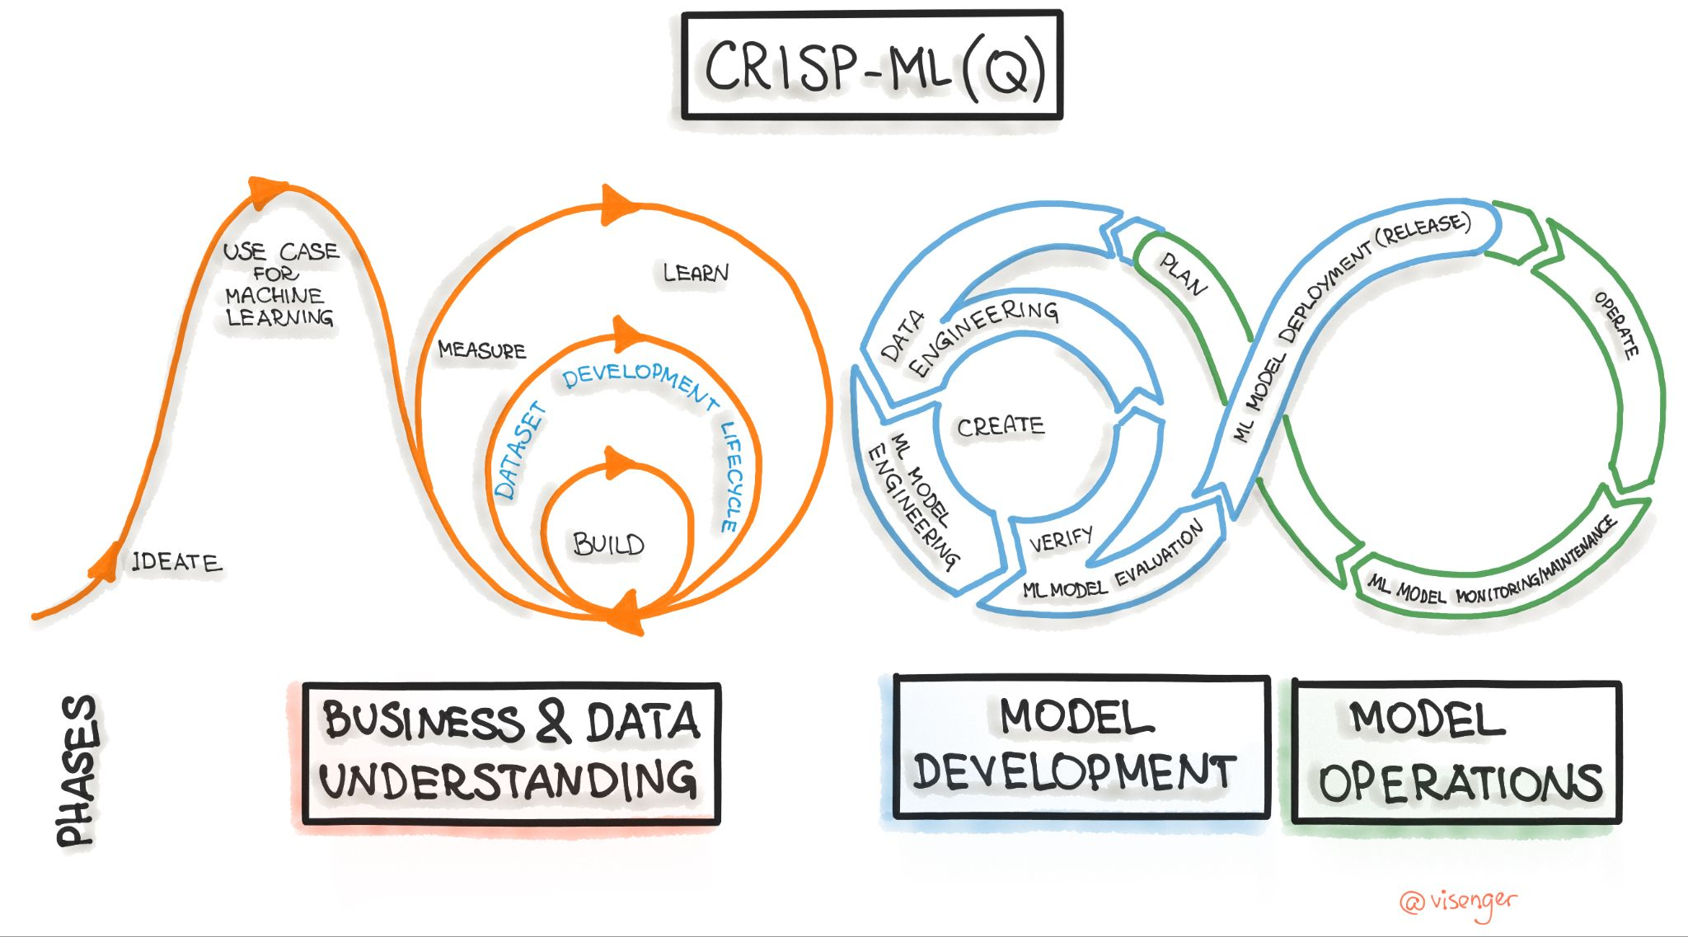
(ML Lifecycle)

